Interactive effects of drought and habitat fragmentation on vital rates of an understory tropical plant

Eric R. Scott1,✉, Maria Uriarte2, and Emilio M. Bruna

22 February, 2021

Text of abstract

1 Department of Wildlife Ecology and Conservation, University of Florida, Gainesville, Florida 32611-0430  
2 Department of Ecology, Evolution and Environmental Biology, Columbia University 1200 Amsterdam Avenue, New York, New York 10027 USA

✉ Correspondence: [Eric R. Scott <[scottericr@gmail.com](mailto:scottericr@gmail.com)>](mailto:scottericr@gmail.com)

Keywords: forest fragmentation; vital rates; *Heliconia acuminata*; drought; ENSO; edge effects

Highlights: These are the highlights

## here() starts at /Users/scottericr/Documents/HeliconiaDemography

# Introduction

1. Organisms simultanously experience multiple forms of natural and anthropogenic disturbance. While work investigating the demographic effects of individual factors is common, studies investigating how multiple factors interact to influence population dynamics remains poorly understood. They could act in concert to exacerbate or dampen population dynamics. For example, fire and herbivory …(Tye et al. 2016).
   * Cite Pedro F. Quintana-Ascencio in intro—he will likely be a reviewer.
   * Cite Jennifer Williams
   * Emphasize demography. We know about interactions on physiology and other stuff, but we don’t know as much about how demography of plants is shaped by how populations respond to multiple stresses, increasingly anthropogenic.
2. Habitat fragmentation is a major source of environmental stress. **[I’m not sure I’d call it a stress…I think the biotic and abioti changes associated with it are stressful]** Forest fragmentation, in particular, is widespread and has resulted in 70% of the Earth’s remaining forest being within 1km of forest edge (Haddad et al. 2015). Of particular concern are the effects of fragmentation on species-rich tropical ecosystems. In the Brazilian Amazon, for example, over 70,000 km of new forest edges are being created annually (Broadbent et al. 2008) and the proportion of forest >1 km from an forest edge has decreased to from 90% to only 75% (Haddad et al. 2015). Fragmentation can impact plant population dynamics through …
3. In addition to the environmental changes associated with fragmentation, populations persisting in tropical forest remnants experience abiotic stress resulting from climate change. For instance, the northern Amazon has been experiencing a drying trend since the mid-1970s, and ensemble climate models predict substantial decreases in dry season precipitation in southern Amazonia for the 21st century (Malhi et al. 2008). Furthermore, droughts induced by the El Niño Southern Oscillation (ENSO) are predicted to increase in frequency and severity (Cai et al. 2014).
   * Drought is bad because…
   * 1997 ENSO drought (Williamson et al. 2000)
   * 2005 ENSO drought (Marengo et al. 2008, Phillips et al. 2009)
   * 2010 drought (Lewis et al. 2011)
4. It has been hypothesized that drought and fragmentation could act in synergy to further reduce population viability in fragmented landscapes, particularly in the tropics (Didham and Lawton 1999, Laurance et al. 2001). Fragmentation drives several changes in microclimate near forest edges, including increased air temperature, decreased relative humidity, reduced soil moisture, and increased penetration of solar radiation in the forest understory (Didham and Lawton 1999, Ewers and Banks-Leite 2013). This decrease in microclimatic buffering could exacerbate the effects of drought in fragments compared to intact forest. This may be why the drought-induced mortality of trees is higher near forest edges than in forest interiors (Laurance et al. 2001, Schwartz et al. 2019).
5. Alternatively, the populations persisting in fragments may be more resilient to drought if individuals susceptible to desiccation died quickly after fragment isolation.
   * (Betts et al. 2019).

* In addition to variation among vital rates, responses to drought and fragmentation could depend on life history stage or plant size. Large established adults could respond differently than seedlings. This is unknown because there are very few systems where we have data on entire life history in a climate change or fragmentation context.
  + Fragmentation affects plant size (in *Heliconia* (Bruna and Oli 2005) and trees (Schwartz et al. 2019)). Smaller/larger plants might be more susceptible to drought. So differential effects of drought in fragments and continuous forest could be due to an interaction between drought and plant size.

To date, however, this hypothesis remains untested for three primary reasons. First, most studies elucidating how tropical plants respond to fragmentation have studied either juvenile (i.e., seed, seedling) or larger, reproductive plants. . . Additionally, while most studies of tropical plant demography focus on trees, little is known about the understory plants that comprise up to ____% of biomass in tropical forests and are ecologically important .

Second, there is a growing literature on how tropical plants respond to droughts, but few studies have compared the responses of plants in continuous forest with those in forest fragments. Laurance et al. (2001) found that the increase in tree (>10 cm DBH) mortality during a drought were exacerbated in fragments, but the decline in mortality after the drought was also stronger in fragments. However, in a temperate system… (Forner et al. 2020).

Finally, the long-term data needed to test population-level hypotheses about climate change-fragmentation synergies are scant, especially for tropical systems (Crone et al. 2011, Salguero-Gomez et al. 2015). However, without multi-decadal sampling one cannot capture enough droughts to quantify their ecological impact, nor the variation in vital rates needed to parameterize demographic models of long-lived species in changing climates (Morris and Doak 2002, Teller et al. 2016). Long-term data are also needed because while some demographic effects of fragmentation or drought on can be detected immediately, others may take years to manifest.

We investigated the effects of drought on the growth, survival, reproduction, and recruitment of a understory herb in an experimentally fragmented landscape in the Central Amazon. Specifically, we asked 1) Does drought increase or decrease the growth, survival, and fertility rates of plant populations in continuous forest? 2) Are the effects of drought on the vital rates of populations in fragments similar in direction and magnitude to those in continuous forest? 3) Are the effects of drought and fragmentation on vital rates consistent across life-history stages?

# Methods

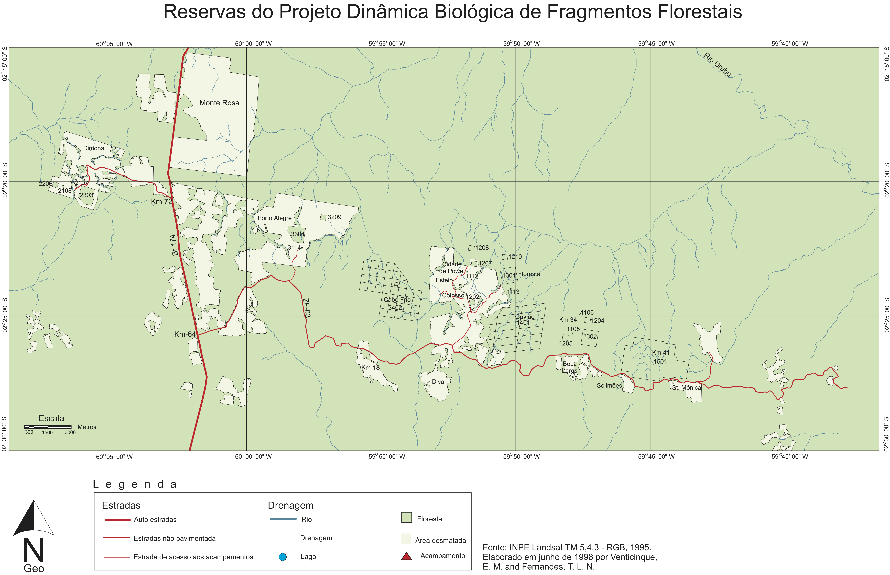

Figure 1: This is just a placeholder figure, but a map or satelite image of BDFFP will go here.

## Study site

The Biological Dynamics of Forest Fragments Project (BDFFP) is located ~70 km north of Manaus, Brazil (2º30’ S, 60ºW). In addition to large areas of continuous forest, the BDFFP has forest fragment reserves that range in size from 1-100 ha (Figure 1). These fragments were isolated from 1980–1984 by felling the trees surrounding the area chosen for isolation and, in most cases, burning the downed trees once they dried. In subsequent decades the vegetation regenerating around fragments has been periodically cleared to ensure fragment isolation (Bierregaard et al. 2001).

The BDFFP reserves are located in nonflooded (i.e., *terra firme*) tropical lowland forest with a 30–37m tall canopy (Rankin-de-Mérona et al. 1992) and an understory dominated by stemless palms (Scariot 1999). The soils in the reserves are nutrient-poor xanthic ferrosols; their water retention capacity is poor despite having a high clay content. Mean annual temperature in the region is 26º C (range=19–39º C), and annual rainfall at the BDFFP reserves ranges from 1900-2300 mm. There is a pronounced dry season from June to October **(Appendix?)**.

## Focal species

*Heliconia acuminata* (LC Rich.) (Heliconiaceae) is a perennial monocot distributed throughout Central Amazonia (Kress 1990); it is the most abundant understory herb at the BDFFP (Ribeiro et al. 2010). While many *Heliconia* species grow in large patches along forest edges or in disturbed areas, others—including as *H. acuminata*—are usually found at lower densities and in the more shaded forest understory. These species produce fewer infloresences and are pollinated by traplining rather than territorial hummingbirds (Berry and Kress 1991). In our sites *H. acuminata* is pollinated by *Phaeothornis superciliosus* and *P. bourcieri* (Bruna et al. 2004); reproductive plants have $\overset{‾}{x}$ = **1.1** flowering shoots (range = 1-7), each of which has an inflorescence with 20–25 flowers (Bruna and Kress 2002). Fruits mature April-May and are consumed by a thrush and several species of manakin (Uriarte et al. 2011). Dispersed seeds (1–3 seeds per fruit, $\overset{‾}{x}$ =2) germinate ~6 months after dispersal at the beginning of the rainy season, and have higher rates of germination and seedling establishment in continuous forest than forest fragments (Bruna 1999, Bruna and Kress 2002). *Heliconia acuminata* is self-incompatible and does not reproduce vegetatively.

## Demographic data collection

In 1997–1998 we established a series of 5000 $m^{2}$ plots ($50×100$ m) in the BDFFP reserves in which we marked and measured all *Heliconia acuminata*. The plots are located in continuous forest (n=6), 10-ha fragments (n=3), and 1-ha fragments (n=4), with distance between plots ranging from 500 m–41 km. Plots in 1-ha fragments were on one randomly selected half of the fragment, plots in 10-ha fragments were in the fragment center, and plots in continuous forest were placed in locations 500-4000 m from the borders of secondary and mature forest (Fig or Table ). Each plot is subdivided into 50 quadrats ($10×10$ m) to simplify the annual surveys, during which we recorded the number of vegetative shoots each plant had, the height of each plant to the tallest leaf, and the identity of any flowering plants. We also surveyed plots regularly during the rainy season to identify any that flowered after the survey. Height and shoot number are correlated with leaf area, the probability of flowering, and rates of survivorship (Bruna 2002, Bruna and Kress 2002). Plants that were not found for three consecutive surveys were considered dead. In 2008 we mapped the location of all established plants to the nearest 10 cm; in subsequent years we did the same with all new seedlings . There is a seven-fold range in *H. acuminata* density in the forest plots, with density in several of the plots comparable to that in low-density fragments (Bruna and Kress 2002).

## Weather data

Precipitation and potential evapotranspiration data were obtained from a published gridded dataset (0.25º x 0.25º resolution) built using data from 3,625 ground-based weather stations across Brazil (Xavier et al. 2016). We used these data to calculate the standardized precipitation evapotranspiration index (SPEI) (Vicente-Serrano et al. 2010). SPEI is a proxy for meteorological drought that integrates precipitation and evapotranspiration anomalies over a specified time scale. Positive SPEI values for a given month indicate conditions wetter than the historical average for that month, while negative values of SPEI indicate droughts with intensity categorized as mild (0 to -1), moderate (-1 to -1.5), severe (-1.5 to -2), or extreme (< -2) (McKee et al. 1993). SPEI can be calculated to represent different temporal scales of drought. We used 3-month SPEI because *H. acuminata* relies primarily on soil moisture rather than deeper water sources that can persist for longer timescales. SPEI calculations were done using the SPEI package in R version 4.0.2 (2020-06-22) (Beguería 2017a, R Core Team 2020). The timing of drought events based on these SPEI calculations is consistent with that resulting from SPEI calculated with other data sources (e.g., nearby weather stations, the global SPEI database (Beguería 2017b), TRMM (“TRMM (TMPA/3B43) rainfall estimate L3 1 month 0.25 degree x 0.25 degree V7” 2011)), though the magnitude of drought can sometimes differ (**Appendix __**).

## Statistical Modeling

We assessed the effects of drought history on plant vital rates using distributed lag non-linear models (DLNMs) (Gasparrini et al. 2017). DLNMs model potentially delayed effects of predictor variables by fitting a bi-dimensional predictor-lag-response association spline, referred to as a crossbasis function. This function allows the effect of a predictor to vary non-linearly through lag time and across predictor intensity. Crossbasis functions were created using the *dlnm* package with possible lags from 0–36 months (Gasparrini 2011, R Core Team 2020). We chose 36 months as a maximum lag because *H. acuminata* individuals transplanted to forest fragments typically recovered from transplant shock within 36 months (Bruna et al. 2002). The crossbasis function was fit to the data in the context of a generalized additive model (GAM) using the *mgcv* package with restricted maximum likelihood (Wood 2017). The general form of the vital rate models was as follows:

Where $s_{1}(x_{i})$ is a smooth function of plant size [ ln(height $×$ shoot number) ], fit using a penalized cubic regression spline, $s_{2}(⋅)$ is the crossbasis function in which $d_{i,t}$ is the SPEI value during the census month of an observation (February) and $d_{i,t−l}$ is the SPEI $l$ months prior (see Gasparrini et al. 2017 for details). The crossbasis function, $s_{2}(⋅)$ can also be written:

$$s_{2}(d_{i,t},...,d_{i,t−24})=\sum_{l=l_{0}}^{L}{f}⋅w(d_{i,t−l},l)$$

Where the crossbasis function, $f⋅w(d,l)$, is composed of two marginal basis functions: the standard predictor-response function $f(d)$, and the additional lag-response function $w(l)$. These marginal functions are combined as a tensor product smooth such that the shape of one marginal function varies smoothly along the other dimension (see Wood (n.d.) and Gasparrini et al. (2017) for more detail). Penalized cubic regression splines were used for both marginal bases of the crossbasis function, with 35 knots for the lag dimension and 3 knots for the drought response dimension to restrict the fitted response to drought to bimodal at most complex. A random effect of plot ID on the intercept is represented by $a_{j}$. For plant growth the response was plant size (natural log of height $×$ shoot number) in year t+1 modeled with a scaled t family error distribution. A scaled t family was chosen because residuals were leptokurtic with a Gaussian error structure. The data on number of infloresences was converted to binary (1 for ≥1 inflorescence, 0 for no inflorescences). When survival and flowering were the response variables we used a binomial family error distribution with a logit link function.

In the process of fitting the models, the penalty on the crossbasis smooth (and other smoothed terms) is optimized such that more linear shapes are favored unless the data supports non-linearity (Wood 2017). We applied an additional penalty to shrink linear portions toward zero with the select=TRUE option to the gam() function, and inferred statistical significance of model terms with p-values from the summary.gam() function as recommended in Marra and Wood (2011).

Because the dlnm package does not currently allow modeling of factor by smooth interactions, we fit separate models for plants in fragments and in continuous forest to allow the shape of the crossbasis function to differ between habitats.

# Results

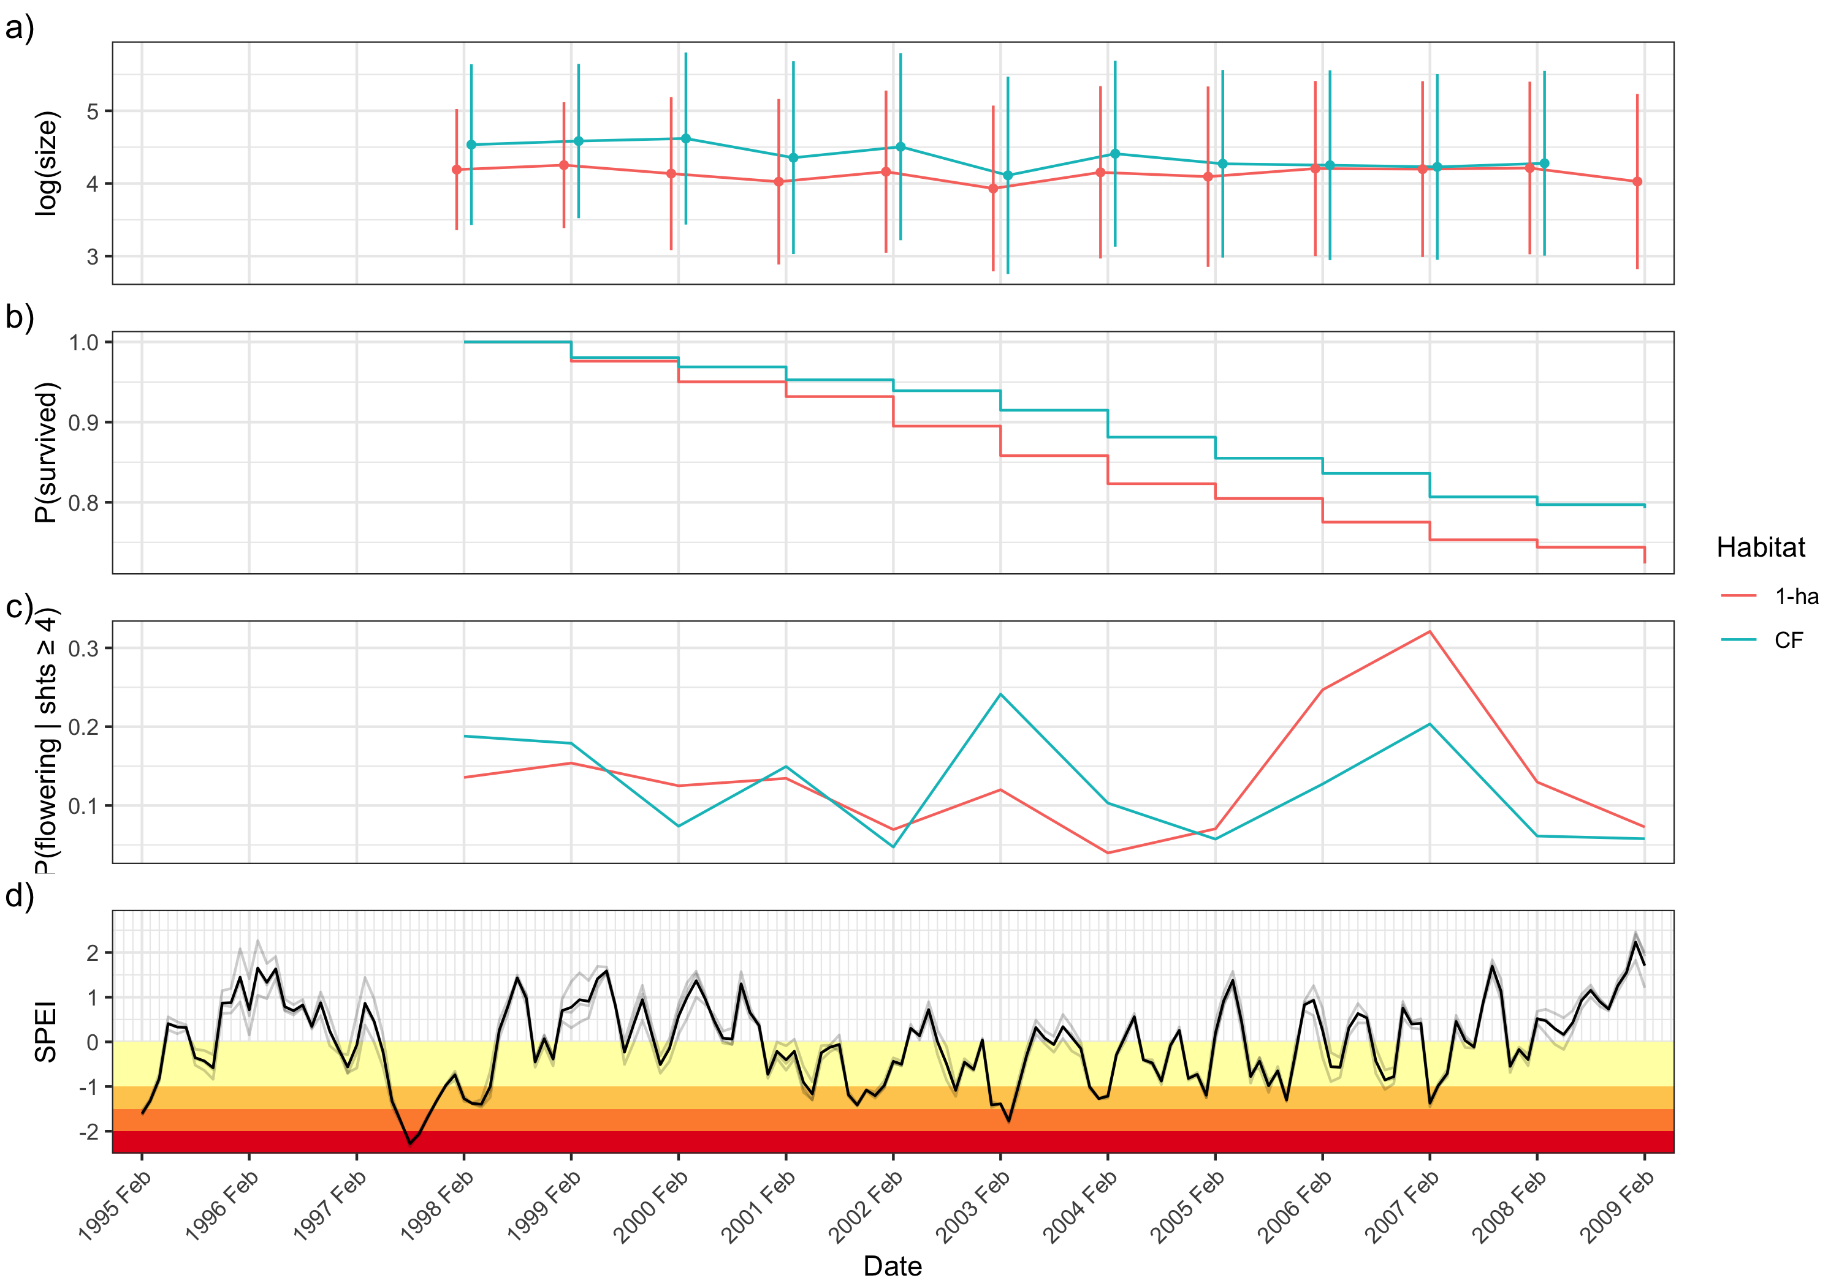

Figure 2: Timeseries of demographic parameters and drought ocurrence. Mean plant size ± standard deviation (a) shows that plants were smaller in fragments (red) than continuous forest (blue). (b) shows the survival curve for the 1998 cohort of plants in both fragments and continuous forest. c) shows the proportion of mature plants (with 4 or more shoots) flowering each census. In d), monthly 3-month SPEI is plotted. Light grey lines represent values from different grid cells encompassing BDFFP and the dark line is the site mean. Yellow, orange, dark orange, and red stripes show mild, moderate, severe, and extreme drought, respectively.

The meteorological drought occurrences indicated by SPEI mostly agree with drought events in the Amazon reported in the literature. For example, the 1997 El Niño drought was one of the most severe droughts in the Amazon on record (Williamson et al. 2000) and correspondingly, 1997 has the lowest SPEI values in our timeseries (Figure 2d).  
The 2005 dry season (June–October) was also reported as exceptionally dry, although this drought mostly affected the south western Amazon (Zeng et al. 2008, Marengo et al. 2008).

Mean plant size dropped dramatically in 2003 in both habitat types, corresponding with the most severe drought in the timeseries (Figure 2d). Two noticeable peaks in the proportion of flowering mature plants occur in the most severe drought years (2003 and 2007) (Figure 2c).

## Survival

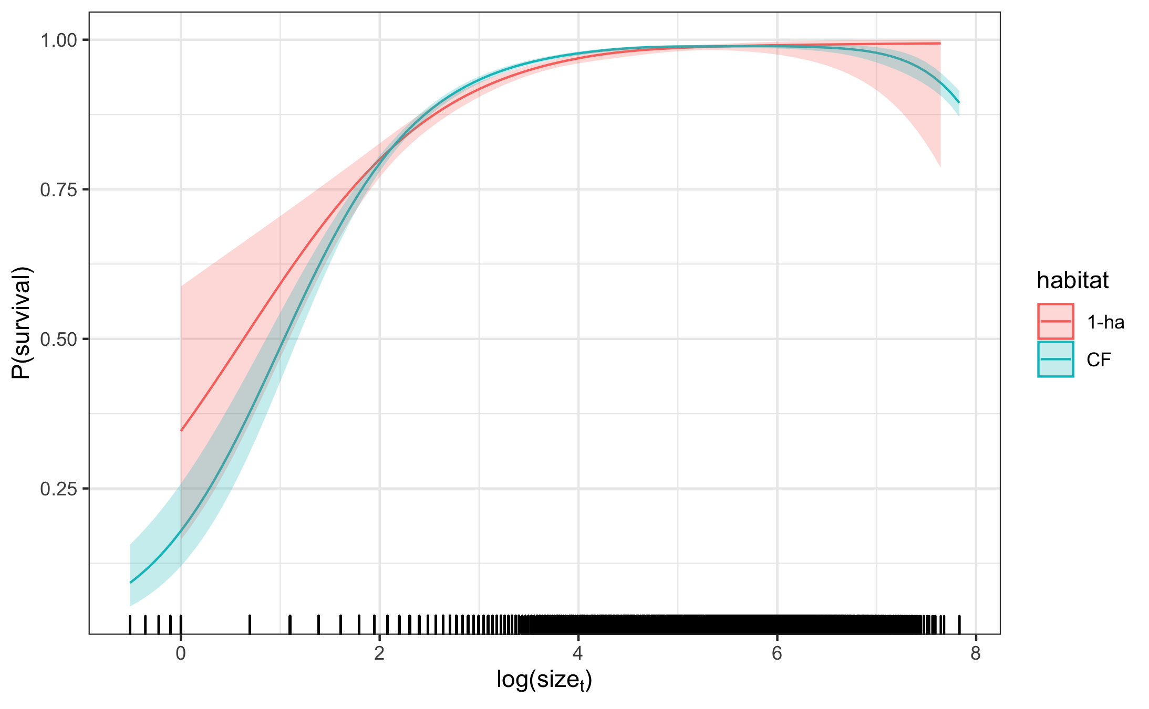

Figure 3: Smooth effect of plant size in the previous census on survival modeled by a cubic regression spline. 95% confidence intervals are shown and include uncertainty in the model intercept and uncertainty due to smoothness selection. The smooths for 1-ha fragments and continuous forest are fit in separate models. The model intercepts were added to the fitted values of the smooth and values are back-transformed to the response scale

Overall survival rate across the entire dataset is 0.95 in both CF and 1-ha. The proportion of surviving plants across both habitat types was lowest in 2004 (0.92) which coincided with a moderate drought in Jan 2004 / Feb 2005 and a severe drought in Jan–Mar of 2004. The lowest survival for 1-ha fragment plots (0.93) was in the 2006 census corresponding to unusually wet weather (SPEI >0.5), but with a moderate drought the preceding October.

Log transformed plant size had a significant effect on survival in both continuous forest and 1-ha fragments (both p < 0.001). Survival probability of large plants approached 1 in both habitat types (Figure 3). Survival of the smallest plants was higher in 1-ha fragments, but the 95% confidence intervals for 1-ha fragments and continuous forest overlapped for all sizes.

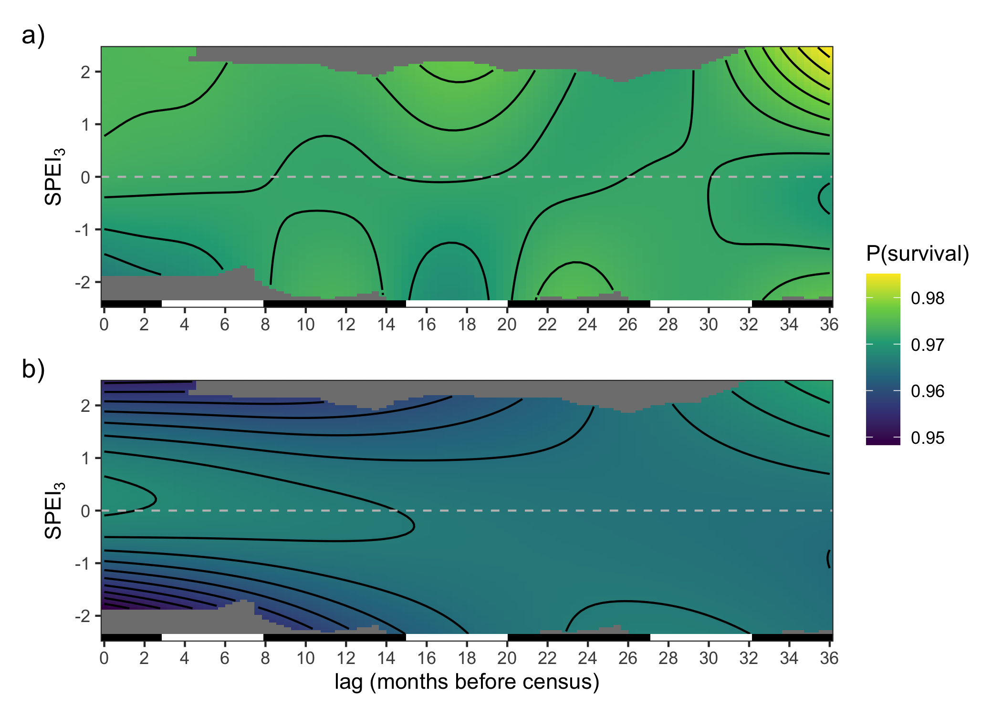

Figure 4: Smooth effect of lagged SPEI on survival in a) continuous forest and b) 1-ha fragments. Surface is modeled as a crossbasis function with cubic regression splines for each marginal basis. Model intercepts were added to fitted values of the crossbasis function and back-transformed to the response scale. Contour lines correspond to a change of 0.002. The bar on the bottom of each panel indicates wet seasons (black, November–May) and dry seasons (white, June–October).

Drought history had a significant effect on survival in both habitats (P < 0.001), but the shape of the crossbasis surface differed. For 1-ha fragments, recent SPEI values had the strongest effect on survival with the highest survival near SPEI of 0 and decreasing survival in both drier and wetter conditions (Figure 4a). In continuous forest, recent SPEI had a weaker effect with only SPEI values less than -1 producing slightly reduced survival probabilities (Figure 4b). However, SPEI at a lag time of 15–20 months, corresponding to June–October of the previous year (i.e. not the most recent dry season, but the one before that), also effected survival probabilities. Lower SPEI (drought) 15–20 months prior to census was associated with reduced survival and higher SPEI at these lag times was associated with higher survival. Plants in both continuous forest and 1-ha fragments showed an increase in survival probability with very high (wet) SPEI values at a lag time of 36 months. However, it should be noted that only the first year of census data (1999) had an SPEI value greater than 2 within 36 months in the past.

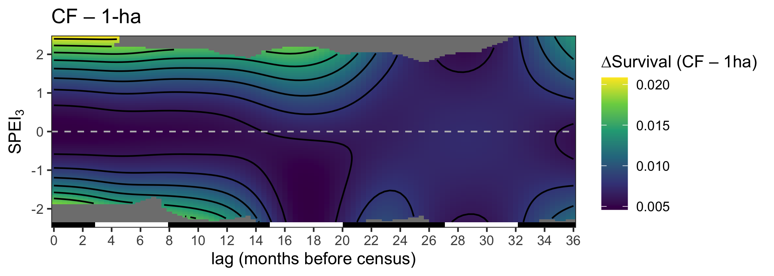

Figure 5: The difference between predicted effects of SPEI history on survival in continuous forest and 1-ha fragments.

Subtracting the estimated contribution of SPEI history to survival in fragments from that in continuous forest shows that in average conditions (SPEI = 0), there is little difference in survival probability between continuous forest and fragments (Figure 5). However, under extreme conditions, survival probability is higher in continuous forest by up to 0.02.

The random effect of plot was significant for continuous forest ( p < 0.001), but not for 1-ha fragments (p = 0.257).

## Growth

Plants were on average larger in continuous forest compared to 1-ha fragments. In continuous forest, plants had an average of 2.9 ± 1.8 shoots (mean ± standard deviation) and were on average 40.6 ± 26.5 cm tall with an average size (shoots $×$ height) of 150 ± 175. In 1-ha fragments, plants had 2.5 ± 1.5 shoots on average and a mean height of 36.2 ± 24.1 cm and a mean size of 112 ± 141. The size difference between plants in continuous forest and 1-ha fragments was more dramatic early on in the timeseries with mean sizes becoming more similar over time (Figure 2a).

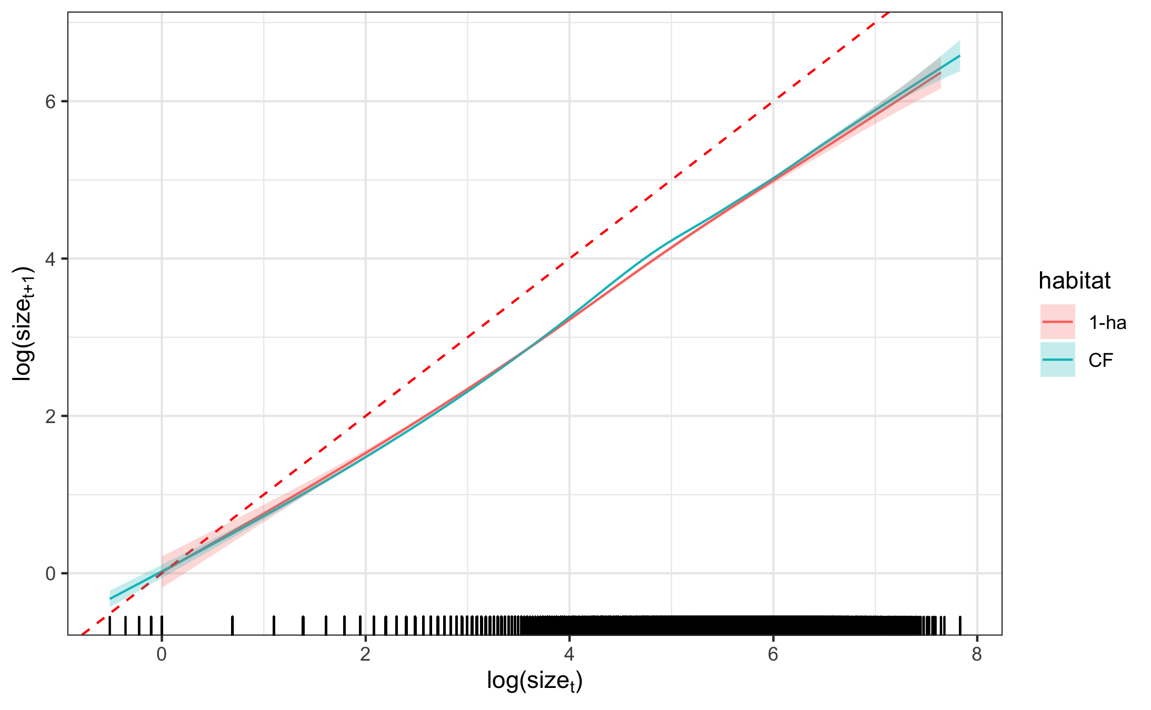

Figure 6: Smooth effect of plant size in year t on plant size in year t+1 modeled by a cubic regression spline. 95% confidence intervals are shown and include uncertainty in the model intercept as well as uncertainty due to smoothness selection. The dashed red line represents a 1:1 line for reference. The smooths for 1-ha fragments and continuous forest are fit in separate models. Model intercepts were added to the fitted values of the smooths.

Log transformed size in year t was a significant predictor of log transformed size in year t+1 (p < 0.001). The 95% confidence intervals for the effect of size in year t in fragments and continuous forest overlapped for most sizes, but was slightly higher in continuous forest for mid-sized plants (Figure 6).

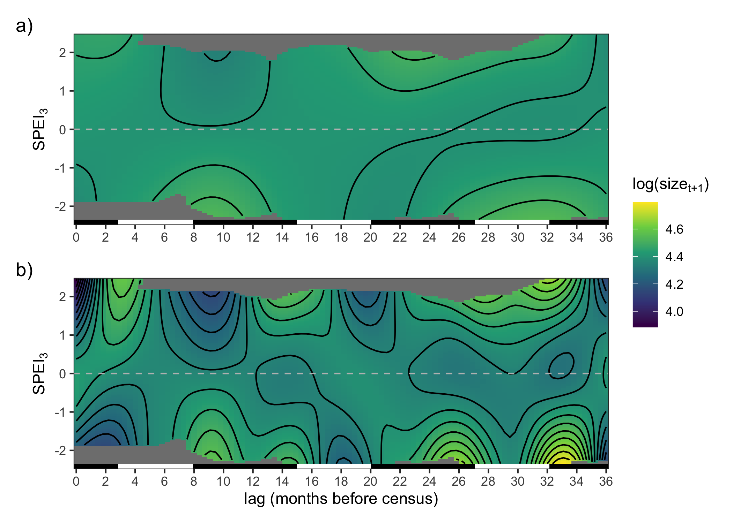

Figure 7: Smooth effect of lagged SPEI on plant growth for a) continuous forest and b) 1-ha fragments. Surface is modeled as a crossbasis function with cubic regression splines for each marginal basis. Model intercepts were added to fitted values of the crossbasis function. Contour lines correspond to a change of 0.05. The bar on the bottom of each panel indicates wet seasons (black, November–May) and dry seasons (white, June–October).

Drought history also had a significant effect on plant size in both habitats (p < 0.001). The fitted crossbasis functions for fragments and continuous forest showed somewhat similar patterns, although the surface for 1-ha fragments was much more complex (edf = 17.9 for 1-ha fragments; edf = 5.9 for continuous forest; see also Figure 7). Drought at lags 8–11 (March - June, the end of the wet season) increase growth in both habitats, but more strongly in 1-ha fragments.

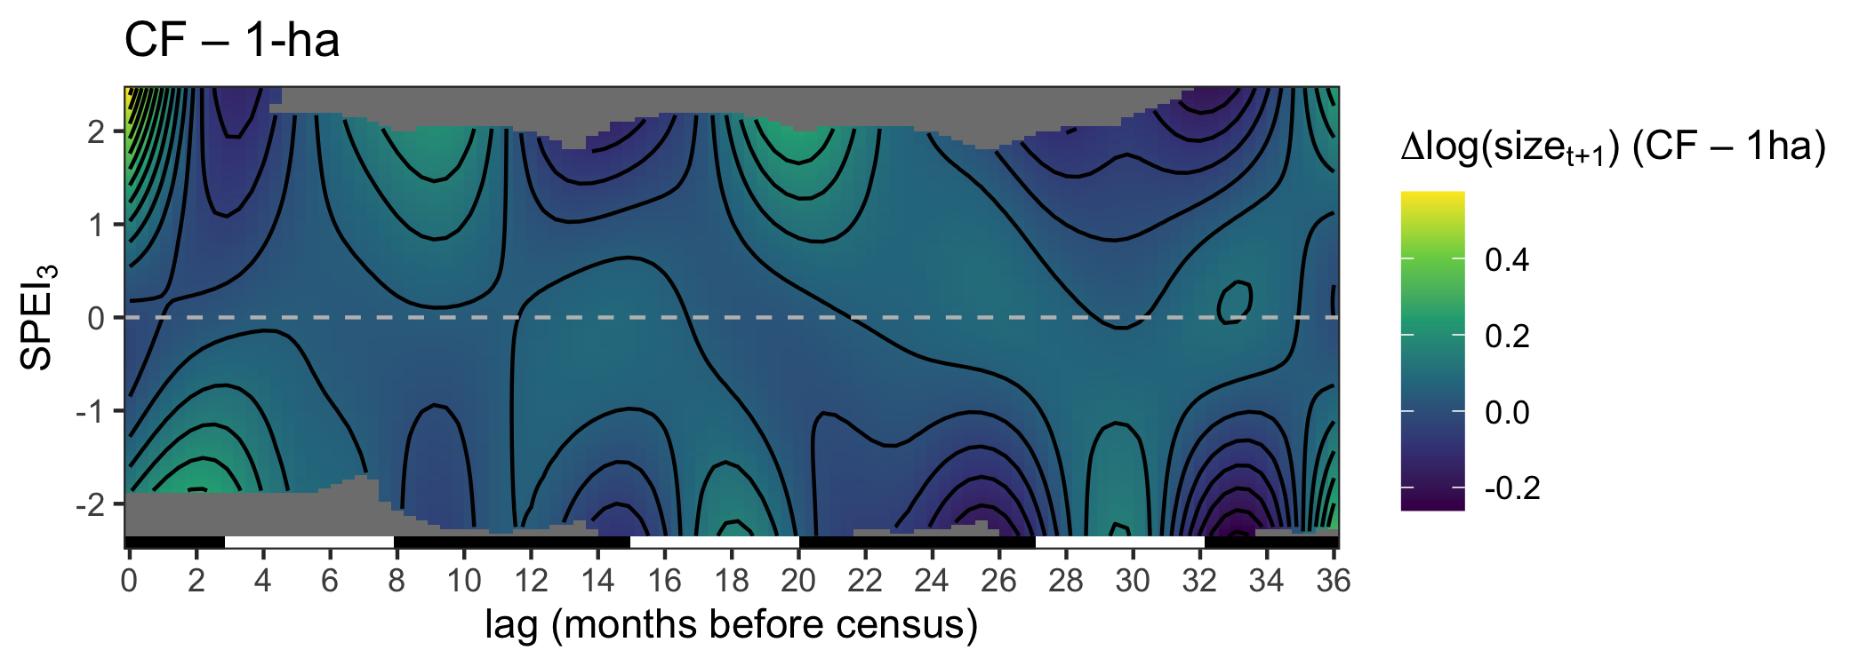

Figure 8: The difference between predicted effects of SPEI history on plant size in continuous forest and 1-ha fragments.

The difference between the effects of SPEI history in continuous forest and 1-ha fragments shows that growth is equal or slightly higher in continuous forest for average conditions (SPEI = 0) over all lag periods (Figure 8. However, growth in continuous forests is higher by up to log(size) = 0.48 when the current wet season is unusually wet (SPEI>1).

The random effect of plot is significant in both habitat models (p < 0.001).

## Flowering

Probability of flowering was generally higher in continuous forest compared to 1-ha fragments. The exceptions to this are in 2006 and 2008 when the proportion of flowering plants was lower in continuous forest (Figure 2c). The most striking difference between habitat types in flowering proportion was in 2003 when 9.7% of plants flowered in the continuous forest plots and only 2.7% flowered in fragment plots.

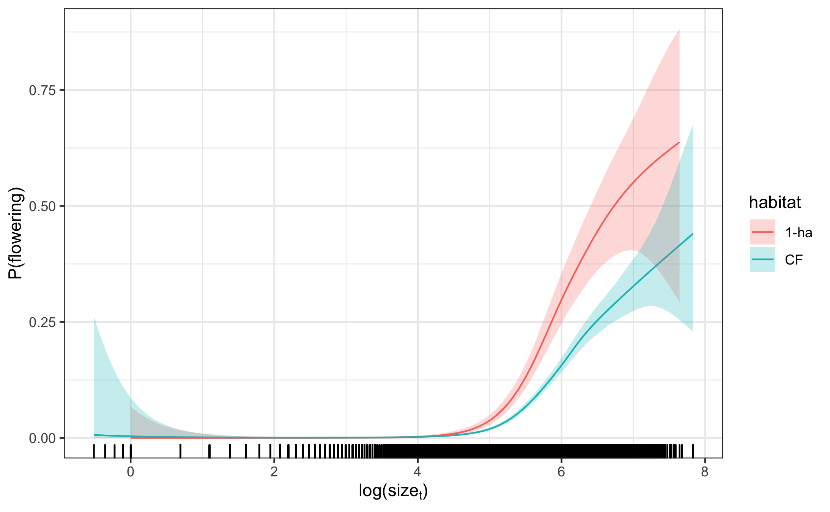

Figure 9: Smooth effect of plant size in the previous census on flowering probability modeled by a cubic regression spline. 95% confidence intervals are shown and include uncertainty in the model intercept as well as uncertainty due to smoothness selection. The smooths for 1-ha fragments and continuous forest are fit in separate models. The model intercepts were added to the fitted values of the smooth and values are back-transformed to the response scale

Plant size had a significant effect on flowering probability in both habitats (p < 0.001). Flowering probability increased rapidly with log-transformed plant size greater than 5 in both habitats (Figure 9). Flowering probability of large plants (log(size) > 5) was greater in 1-ha fragments compared to continuous forest. However, because mean plant size is larger in continuous forest, overall flowering probability was greater.

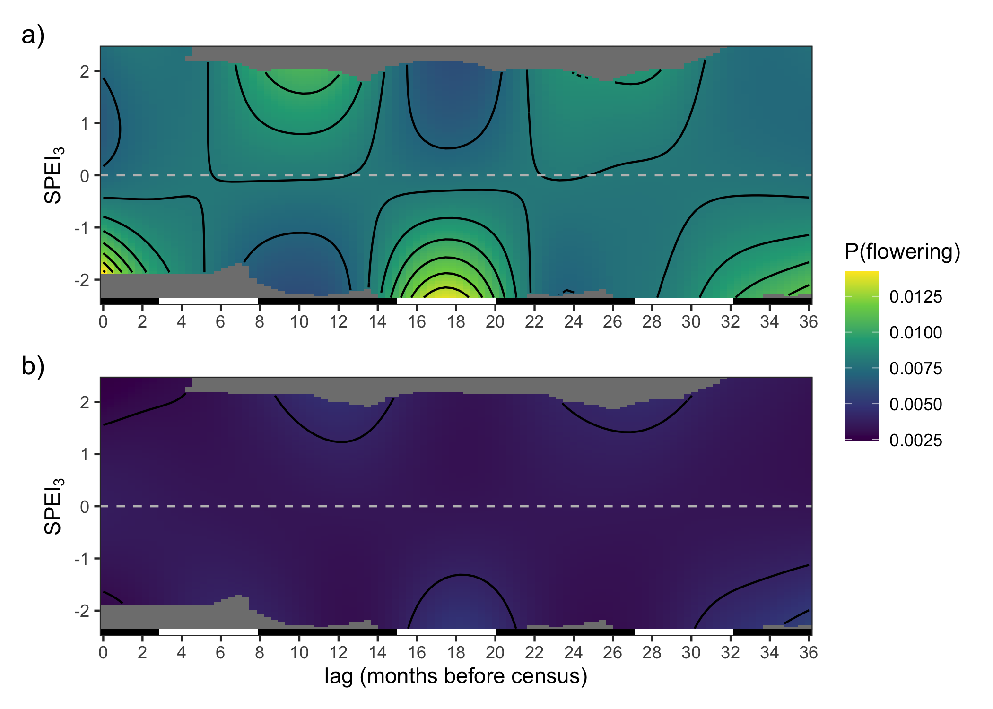

Figure 10: Smooth effect of lagged SPEI on flowering probability. Surface is modeled as a crossbasis function with cubic regression splines for each marginal basis. Model intercepts were added to fitted values of the crossbasis function and back-transformed to the response scale. Contour lines correspond to a change of 0.001. The bar on the bottom of each panel indicates wet seasons (black, November–May) and dry seasons (white, June–October).

Drought history had a significant effect on flowering probability in both habitat types (p < 0.001). Flowering probability was overall higher at all values of SPEI in continuous forest compared to 1-ha fragments (Figure 10). The effects of SPEI on flowering probability were also stronger and more complex in continuous forest compared to fragments (1-ha edf = 8.5, continuous forest edf = 10.5). In continuous forest, flowering probability was increased by recent drought (at lag = 0 with SPEI < -1) and drought at lags 15–20 (Jun-Nov, the dry season in the previous year). Drought at lags 7–13 reduced flowering probability. The shape of the crossbasis function was similar in 1-ha fragments, but significantly muted (Figure 10a). That is, the variation in fitted values along the SPEI dimension was much lower at all values of the lag dimension in fragments.

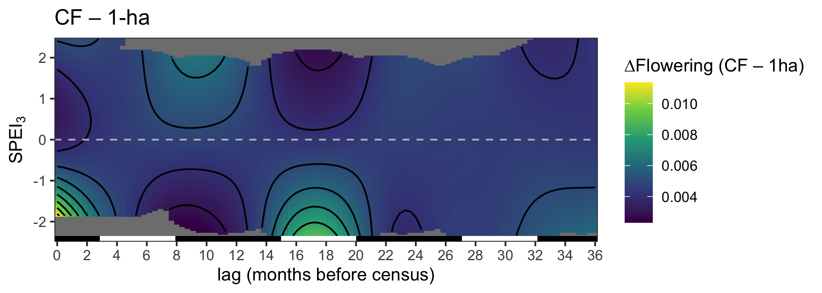

Figure 11: The difference between predicted effects of SPEI history on flowering probability in continuous forest and 1-ha fragments.

Plotting the difference between the crossbasis smooths for continuous forest and 1-ha fragments revealed that flowering probability is higher in continuous forest compared to 1-ha fragments and is increased by recent drought and drought during the dry season 15–20 months prior to the census (Figure 11). The least difference between habitat types occurs when there is strong drought at about 8–12 months lag or very wet conditions at 15–20 months lag.

The random effect of plot also had a significant effect in both habitats (p < 0.001).

# Discussion

Caveats:

One limitation of the DLNM approach is that it does not currently allow for modeling of interactions with a crossbasis function. This limitation meant that we were unable to model a potential size by environment (i.e. drought history) interaction, which may occur with many plant species (Tredennick et al. 2018). To check for a size by environment interaction, we followed the methods of Tredennick et al. (2018) and fit a pair of generalized linear mixed effects models (GLMMs) for each vital rate using the *lme4* package (Bates et al. 2015). Rather than explicitly modeling the effects of drought history, we modeled environmental stochasticity with random effects of year. For each vital rate, we essentially replaced the crossbasis function in Eq 1. with a random effect of year on either the intercept or both the intercept and relationship with plant size. We assessed the significance of the year-by-size interaction by testing the likelihood ratio of models with and without the interaction against an expected likelihood ratio distribution under the null hypothesis of no interaction (Tredennick et al. 2018).

# Conclusion

# Acknowledgments

We thank —-, —-, —-, and — anonymous reviewers for helpful discussions and comments on the manuscript. We also thank the technicians and students who helped conduct the *Heliconia* censuses and the BDFFP and INPA for logistical support. Financial support was provided by the U.S. National Science Foundation (awards DEB-0614339, DEB-0614149, INT 98-06351, and DEB-1948607). This is publication No. —- in the BDFFP Technical Series.

If TRMM data is used, they suggest: “The TMPA data were provided by the  
NASA/Goddard Space Flight Center’s Mesoscale Atmospheric Processes Laboratory and  
PPS, which develop and compute the TMPA as a contribution to TRMM.”

# References

Bates, D., M. Mächler, B. Bolker, and S. Walker. 2015. Fitting linear mixed-effects models using lme4. Journal of Statistical Software 67:1–48.

Beguería, S. 2017a. Sbegueria/SPEIbase: Version 2.5.1. Zenodo.

Beguería, S. 2017b, July. Sbegueria/SPEIbase: Version 2.5.1. Zenodo.

Berry, F., and W. J. Kress. 1991. Heliconia: An identification guide. Smithsonian Institution Press, Washington D.C., USA.

Betts, M. G., C. Wolf, M. Pfeifer, C. Banks-Leite, V. Arroyo-Rodríguez, D. B. Ribeiro, J. Barlow, F. Eigenbrod, D. Faria, R. J. Fletcher, A. S. Hadley, J. E. Hawes, R. D. Holt, B. Klingbeil, U. Kormann, L. Lens, T. Levi, G. F. Medina-Rangel, S. L. Melles, D. Mezger, J. C. Morante-Filho, C. D. L. Orme, C. A. Peres, B. T. Phalan, A. Pidgeon, H. Possingham, W. J. Ripple, E. M. Slade, E. Somarriba, J. A. Tobias, J. M. Tylianakis, J. N. Urbina-Cardona, J. J. Valente, J. I. Watling, K. Wells, O. R. Wearn, E. Wood, R. Young, and R. M. Ewers. 2019. Extinction filters mediate the global effects of habitat fragmentation on animals. Science 366:1236–1239.

Bierregaard, R. O., C. Gascon, T. E. Lovejoy, and R. Mesquita, editors. 2001. Lessons from Amazonia: The ecology and conservation of a fragmented forest. Yale University Press, New Haven.

Bierregaard, R. O., C. Gascon, T. E. Lovejoy, and R. Mesquita, editors. 2001. Lessons from Amazonia: The ecology and conservation of a fragmented forest. Yale University Press, New Haven.

Broadbent, E. N., G. P. Asner, M. Keller, D. E. Knapp, P. J. C. Oliveira, and J. N. Silva. 2008. Forest fragmentation and edge effects from deforestation and selective logging in the Brazilian Amazon. Biological Conservation 141:1745–1757.

Bruna, E. M. 1999. Seed germination in rainforest fragments. Nature 402:139.

Bruna, E. M. 2002. Effects of forest fragmentation on Heliconia acuminata seedling recruitment in central Amazonia. Oecologia 132:235–243.

Bruna, E. M., and W. J. Kress. 2002. Habitat Fragmentation and the Demographic Structure of an Amazonian Understory Herb (Heliconia acuminata). Conservation Biology 16:1256–1266.

Bruna, E. M., W. J. Kress, F. Marques, and O. F. da Silva. 2004. Heliconia acuminata reproductive success is independent of local floral density. Acta Amazonica 34:467–471.

Bruna, E. M., O. Nardy, S. Y. Strauss, and S. Harrison. 2002. Experimental assessment of Heliconia acuminata growth in a fragmented Amazonian landscape. Journal of Ecology:11.

Bruna, E. M., and M. K. Oli. 2005. Demographic effects of habitat fragmentation on a tropical herb: life-table response experiments. Ecology 86:1816–1824.

Cai, W., S. Borlace, M. Lengaigne, P. van Rensch, M. Collins, G. Vecchi, A. Timmermann, A. Santoso, M. J. McPhaden, L. Wu, M. H. England, G. Wang, E. Guilyardi, and F.-F. Jin. 2014. Increasing frequency of extreme El Niño events due to greenhouse warming. Nature Climate Change 4:111–116.

Crone, E. E., E. S. Menges, M. M. Ellis, T. Bell, P. Bierzychudek, J. Ehrlen, T. N. Kaye, T. M. Knight, P. Lesica, W. F. Morris, G. Oostermeijer, P. F. Quintana-Ascencio, A. Stanley, T. Ticktin, T. Valverde, and J. L. Williams. 2011. How do plant ecologists use matrix population models? Ecology Letters 14:1–8.

Didham, R. K., and J. H. Lawton. 1999. Edge Structure Determines the Magnitude of Changes in Microclimate and Vegetation Structure in Tropical Forest Fragments. Biotropica 31:17–30.

Didham, R. K., and J. H. Lawton. 1999. Edge Structure Determines the Magnitude of Changes in Microclimate and Vegetation Structure in Tropical Forest Fragments. Biotropica 31:17–30.

Didham, R. K., and J. H. Lawton. 1999. Edge Structure Determines the Magnitude of Changes in Microclimate and Vegetation Structure in Tropical Forest Fragments. Biotropica 31:17–30.

Ewers, R. M., and C. Banks-Leite. 2013. Fragmentation Impairs the Microclimate Buffering Effect of Tropical Forests. PLoS ONE 8:e58093.

Forner, A., T. Morán-López, D. Flores-Rentería, I. Aranda, and F. Valladares. 2020. Fragmentation reduces severe drought impacts on tree functioning in holm oak forests. Environmental and Experimental Botany 173:104001.

Gasparrini, A. 2011. Distributed Lag Linear and Non-Linear Models in *R* : The Package **dlnm**. Journal of Statistical Software 43.

Gasparrini, A., F. Scheipl, B. Armstrong, and M. G. Kenward. 2017. A penalized framework for distributed lag non-linear models: Penalized DLNMs. Biometrics 73:938–948.

Haddad, N. M., L. A. Brudvig, J. Clobert, K. F. Davies, A. Gonzalez, R. D. Holt, T. E. Lovejoy, J. O. Sexton, M. P. Austin, C. D. Collins, W. M. Cook, E. I. Damschen, R. M. Ewers, B. L. Foster, C. N. Jenkins, A. J. King, W. F. Laurance, D. J. Levey, C. R. Margules, B. A. Melbourne, A. O. Nicholls, J. L. Orrock, D.-X. Song, and J. R. Townshend. 2015. Habitat fragmentation and its lasting impact on Earth’s ecosystems. Science Advances 1:e1500052.

Kress, J. 1990. The diversity and distribution of Heliconia (Heliconiaceae) in Brazil. Acta Botanica Brasileira 4:159–167.

Laurance, W. F., G. B. Williamson, P. Delamônica, A. Oliveira, T. E. Lovejoy, C. Gascon, and L. Pohl. 2001. Effects of a Strong Drought on Amazonian Forest Fragments and Edges. Journal of Tropical Ecology 17:771–785.

Laurance, W. F., G. B. Williamson, P. Delamônica, A. Oliveira, T. E. Lovejoy, C. Gascon, and L. Pohl. 2001. Effects of a Strong Drought on Amazonian Forest Fragments and Edges. Journal of Tropical Ecology 17:771–785.

Laurance, W. F., G. B. Williamson, P. Delamônica, A. Oliveira, T. E. Lovejoy, C. Gascon, and L. Pohl. 2001. Effects of a Strong Drought on Amazonian Forest Fragments and Edges. Journal of Tropical Ecology 17:771–785.

Lewis, S. L., P. M. Brando, O. L. Phillips, G. M. F. van der Heijden, and D. Nepstad. 2011. The 2010 Amazon Drought. Science 331:554–554.

Malhi, Y., J. T. Roberts, R. A. Betts, T. J. Killeen, W. Li, and C. A. Nobre. 2008. Climate Change, Deforestation, and the Fate of the Amazon. Science 319:169–172.

Marengo, J. A., C. A. Nobre, J. Tomasella, M. D. Oyama, G. Sampaio de Oliveira, R. de Oliveira, H. Camargo, L. M. Alves, and I. F. Brown. 2008. The Drought of Amazonia in 2005. Journal of Climate 21:495–516.

Marra, G., and S. N. Wood. 2011. Practical variable selection for generalized additive models. Computational Statistics & Data Analysis 55:2372–2387.

McKee, T. B., N. J. Doesken, and J. Kleist. 1993. The Relationship of Drought Frequency and Duration to Time Scales.

Morris, W. F., and D. F. Doak. 2002. Quantitative conservation biology: Theory and practice of population viability analysis. Sinauer, Sunderland, MA.

Phillips, O. L., L. E. O. C. Aragao, S. L. Lewis, J. B. Fisher, J. Lloyd, G. Lopez-Gonzalez, Y. Malhi, A. Monteagudo, J. Peacock, C. A. Quesada, G. van der Heijden, S. Almeida, I. Amaral, L. Arroyo, G. Aymard, T. R. Baker, O. Banki, L. Blanc, D. Bonal, P. Brando, J. Chave, A. C. A. de Oliveira, N. D. Cardozo, C. I. Czimczik, T. R. Feldpausch, M. A. Freitas, E. Gloor, N. Higuchi, E. Jimenez, G. Lloyd, P. Meir, C. Mendoza, A. Morel, D. A. Neill, D. Nepstad, S. Patino, M. C. Penuela, A. Prieto, F. Ramirez, M. Schwarz, J. Silva, M. Silveira, A. S. Thomas, H. t. Steege, J. Stropp, R. Vasquez, P. Zelazowski, E. A. Davila, S. Andelman, A. Andrade, K.-J. Chao, T. Erwin, A. Di Fiore, E. H. C., H. Keeling, T. J. Killeen, W. F. Laurance, A. P. Cruz, N. C. A. Pitman, P. N. Vargas, H. Ramirez-Angulo, A. Rudas, R. Salamao, N. Silva, J. Terborgh, and A. Torres-Lezama. 2009. Drought Sensitivity of the Amazon Rainforest. Science 323:1344–1347.

R Core Team. 2020. R: A language and environment for statistical computing. Vienna, Austria.

Rankin-de-Mérona, J. M., G. T. Prance, R. W. Hutchings, M. F. da Silva, W. A. Rodrigues, and M. E. Uehling. 1992. Preliminary results of a large-scale tree inventory of upland rain forest in the central Amazon. Acta Amazonica 22:493–534.

Ribeiro, M. B. N., E. M. Bruna, and W. Mantovani. 2010. Influence of post-clearing treatment on the recovery of herbaceous plant communities in amazonian secondary forests. Restoration Ecology 18:50–58.

Salguero-Gomez, R., O. R. Jones, C. R. Archer, Y. M. Buckley, J. Che-Castaldo, H. Caswell, D. Hodgson, A. Scheuerlein, D. A. Conde, E. Brinks, H. de Buhr, C. Farack, F. Gottschalk, A. Hartmann, A. Henning, G. Hoppe, G. Roemer, J. Runge, T. Ruoff, J. Wille, S. Zeh, R. Davison, D. Vieregg, A. Baudisch, R. Altwegg, F. Colchero, M. Dong, H. de Kroon, J. D. Lebreton, C. J. E. Metcalf, M. M. Neel, I. M. Parker, T. Takada, T. Valverde, L. A. Velez-Espino, G. M. Wardle, M. Franco, and J. W. Vaupel. 2015. The COMPADRE Plant Matrix Database: An open online repository for plant demography. Journal of Ecology 103:202–218.

Scariot, A. 1999. Forest fragmentation effects on palm diversity in central Amazonia. Journal of Ecology 87:66–76.

Schwartz, N. B., A. M. Budsock, and M. Uriarte. 2019. Fragmentation, forest structure, and topography modulate impacts of drought in a tropical forest landscape. Ecology 100:e02677.

Teller, B. J., P. B. Adler, C. B. Edwards, G. Hooker, and S. P. Ellner. 2016. Linking demography with drivers: climate and competition. Methods in Ecology and Evolution 7:171–183.

Tredennick, A. T., Brittany J. Teller, P. B. Adler, G. Hooker, and S. P. Ellner. 2018. Size-by-environment interactions: a neglected dimension of species’ responses to environmental variation. Ecology Letters 21:1757–1770.

TRMM (TMPA/3B43) rainfall estimate L3 1 month 0.25 degree x 0.25 degree V7. 2011. Goddard Earth Sciences Data; Information Services Center (GES DISC), Greenbelt, MD.

Tye, M. R., E. S. Menges, C. Weekley, P. F. Quintana-Ascencio, and R. Salguero-Gómez. 2016. A demographic ménage à trois: interactions between disturbances both amplify and dampen population dynamics of an endemic plant. Journal of Ecology 104:1778–1788.

Uriarte, M., M. Anciães, M. T. B. da Silva, P. Rubim, E. Johnson, and E. M. Bruna. 2011. Disentangling the drivers of reduced long-distance seed dispersal by birds in an experimentally fragmented landscape. Ecology 92:924–937.

Vicente-Serrano, S. M., S. Beguería, and J. I. López-Moreno. 2010. A Multiscalar Drought Index Sensitive to Global Warming: The Standardized Precipitation Evapotranspiration Index. Journal of Climate 23:1696–1718.

Williamson, G. B., W. F. Laurance, A. A. Oliveira, P. Delamônica, C. Gascon, T. E. Lovejoy, and L. Pohl. 2000. Amazonian Tree Mortality during the 1997 El Niño Drought. Conservation Biology 14:1538–1542.

Wood, S. N. 2017. Generalized additive models: An introduction with r. Second edition. CRC Press/Taylor & Francis Group, Boca Raton.

Wood, S. N. (n.d.). Chapter 5: Smoothers. Pages 195–247 Generalized additive models: An introduction with R.

Xavier, A. C., C. W. King, and B. R. Scanlon. 2016. Daily gridded meteorological variables in Brazil (19802013). International Journal of Climatology 36:2644–2659.

Zeng, N., J.-H. Yoon, J. A. Marengo, A. Subramaniam, C. A. Nobre, A. Mariotti, and J. D. Neelin. 2008. Causes and impacts of the 2005 Amazon drought. Environmental Research Letters 3:014002.

### Colophon

This report was generated on 2021-02-22 13:45:12 using the following computational environment and dependencies:

#> ─ Session info ───────────────────────────────────────────────────────────────  
#> setting value   
#> version R version 4.0.2 (2020-06-22)  
#> os macOS Catalina 10.15.7   
#> system x86_64, darwin17.0   
#> ui X11   
#> language (EN)   
#> collate en_US.UTF-8   
#> ctype en_US.UTF-8   
#> tz America/New_York   
#> date 2021-02-22   
#>   
#> ─ Packages ───────────────────────────────────────────────────────────────────  
#> ! package * version date lib source   
#> P assertthat 0.2.1 2019-03-21 [?] CRAN (R 4.0.0)  
#> P bookdown 0.21 2020-10-13 [?] CRAN (R 4.0.2)  
#> callr 3.5.1 2020-10-13 [1] CRAN (R 4.0.2)  
#> P cli 2.2.0 2020-11-20 [?] CRAN (R 4.0.2)  
#> crayon 1.4.1 2021-02-08 [1] CRAN (R 4.0.2)  
#> P desc 1.2.0 2018-05-01 [?] CRAN (R 4.0.0)  
#> P devtools 2.3.2 2020-09-18 [?] CRAN (R 4.0.2)  
#> digest 0.6.27 2020-10-24 [1] CRAN (R 4.0.2)  
#> P ellipsis 0.3.1 2020-05-15 [?] CRAN (R 4.0.0)  
#> P evaluate 0.14 2019-05-28 [?] CRAN (R 4.0.0)  
#> P fansi 0.4.1 2020-01-08 [?] CRAN (R 4.0.0)  
#> P fs 1.5.0 2020-07-31 [?] CRAN (R 4.0.2)  
#> P glue 1.4.2 2020-08-27 [?] CRAN (R 4.0.2)  
#> P here * 1.0.1 2020-12-13 [?] CRAN (R 4.0.2)  
#> P highr 0.8 2019-03-20 [?] CRAN (R 4.0.0)  
#> P htmltools 0.5.0 2020-06-16 [?] CRAN (R 4.0.0)  
#> P knitr * 1.30 2020-09-22 [?] CRAN (R 4.0.2)  
#> P lifecycle 0.2.0 2020-03-06 [?] CRAN (R 4.0.0)  
#> P magrittr 2.0.1 2020-11-17 [?] CRAN (R 4.0.2)  
#> P memoise 1.1.0 2017-04-21 [?] CRAN (R 4.0.0)  
#> P pkgbuild 1.2.0 2020-12-15 [?] CRAN (R 4.0.2)  
#> P pkgload 1.1.0 2020-05-29 [?] CRAN (R 4.0.0)  
#> P png 0.1-7 2013-12-03 [?] CRAN (R 4.0.0)  
#> P prettyunits 1.1.1 2020-01-24 [?] CRAN (R 4.0.0)  
#> P processx 3.4.5 2020-11-30 [?] CRAN (R 4.0.2)  
#> P ps 1.5.0 2020-12-05 [?] CRAN (R 4.0.2)  
#> P purrr 0.3.4 2020-04-17 [?] CRAN (R 4.0.0)  
#> R6 2.5.0 2020-10-28 [1] CRAN (R 4.0.2)  
#> P remotes 2.2.0 2020-07-21 [?] CRAN (R 4.0.2)  
#> P rlang 0.4.10 2020-12-30 [?] CRAN (R 4.0.2)  
#> P rmarkdown 2.6 2020-12-14 [?] CRAN (R 4.0.2)  
#> P rprojroot 2.0.2 2020-11-15 [?] CRAN (R 4.0.2)  
#> P sessioninfo 1.1.1 2018-11-05 [?] CRAN (R 4.0.2)  
#> P stringi 1.5.3 2020-09-09 [?] CRAN (R 4.0.2)  
#> P stringr 1.4.0 2019-02-10 [?] CRAN (R 4.0.0)  
#> P testthat 3.0.1 2020-12-17 [?] CRAN (R 4.0.2)  
#> P usethis 2.0.0 2020-12-10 [?] CRAN (R 4.0.2)  
#> withr 2.3.0 2020-09-22 [1] CRAN (R 4.0.2)  
#> P xfun 0.20 2021-01-06 [?] CRAN (R 4.0.2)  
#> P yaml 2.2.1 2020-02-01 [?] CRAN (R 4.0.0)  
#>   
#> [1] /Users/scottericr/Documents/HeliconiaDemography/renv/library/R-4.0/x86_64-apple-darwin17.0  
#> [2] /private/var/folders/b_/2vfnxxls5vs401tmhhb3wqdh0000gp/T/RtmpEvM7V7/renv-system-library  
#> [3] /Library/Frameworks/R.framework/Versions/4.0/Resources/library  
#>   
#> P ── Loaded and on-disk path mismatch.

The current Git commit details are:

#> Local: master /Users/scottericr/Documents/HeliconiaDemography  
#> Remote: master @ origin (https://github.com/BrunaLab/HeliconiaDemography.git)  
#> Head: [11ba138] 2021-02-19: sentence wrap.